

**University Institute of Information Technology,**

**PMAS-Arid Agriculture University,**

**Rawalpindi Pakistan**

**Project Name**

**IOT Based Smart Animals Market with Tracking app**

***By***

**Sameer Akhter 18-ARID-2924**

**Shahab Ahmad 18-ARID-2927**

**Shahzad Hussain 18-ARID-2929**

***Supervisor*Mr. Zeeshan Javed**

***Bachelor of Science in Information Technology***

***(2018-2022)***

**DECLARATION**

We hereby declare that this software, neither whole nor as a part has been copied out from any source. It is further declared that we have developed this software documentation and accompanied report entirely on the basis of our personal efforts. If any part of this project is proved to be copied out from any source or found to be reproduction of some other. We will stand by the consequences. No Portion of the work presented has been submitted of any application for any other degree or qualification of this or any other university or institute of learning.

Sameer Akhter Shahab Ahmad Shahzad hussain

--------------------------- --------------------------- ---------------------------

**CERTIFICATE OF APPROVAL**

It is to certify that the final year project of BS (IT) “IOT Based Smart Animals Market with Tracking App” was developed by “Sameer Akhter**, 18-Arid-2924”**, “Shahab Ahmad**, 18-Arid-2927”** and “**Shahzad Hussain, 18-Arid-2929”** under the supervision of “Mr. Zeeshan Javed” and that in their opinion; it is fully adequate, in scope and quality for the degree of Bachelors of Science in Information Technology.

---------------------------------------

**Supervisor**

---------------------------------------

**(Mr. Imran Khurram OR Mr. Zeeshan Javed)**

**External Examiner**

---------------------------------------

**Administrator UIIT**

**Executive Summary**

In public places, there is often a need for monitoring people and different activities going on, which can be referred later for many reasons including security. Appointing humans for this task involves many problems such as increased employee hiring, accuracy problem, trust, no proof for later use, and also the fact that a human can remember things till a certain time limit. Talking about the current security system, they use dumb still cameras with a continuous recording facility irrespective of the fact that any event may happen or not. Moreover they are usually pointing at a specific user defined locations so more than one cameras are required to cover the entire region.

To prevent all these problems from prevailing, the CSCS is developed. It is a surveillance system, which provides solution to many of these problems. It is a stand-alone application which doesn’t require any computer to operate. It monitors different situations using a camera which is able to rotate intelligently based on sensor messages and captures the scene in the form of video or photos later reference as well.

**C**ustomizable **S**urveillance **C**ontrol **S**ystem **(CSCS)** is a surveillance system that can be assigned a sensor type as in our case a heat sensor is used, it works accordingly, rotates the camera upon event detection and perform user defined actions like capturing video and stores them, for the future use.

It is an embedded system consisting of Linux fox kit with embedded a running server application also a camera, USB storage device and a sensor node base station is attached with fox kit. LAN communication is used by user to download the videos and to operate the system manually.

**Acknowledgement**

All praise is to Almighty Allah who bestowed upon us a minute portion of His boundless knowledge by virtue of which we were able to accomplish this challenging task.

We are greatly indebted to our project supervisor “Mr Zeeshan javed” and our Co-Supervisor “Saif ” for personal supervision, advice, valuable guidance and completion of this project. We are deeply indebted to him/her/them for encouragement and continual help during this work.

And we are also thankful to our parents and family who have been a constant source of encouragement for us and brought us the values of honesty & hard work.

Student Name 1 Student Name 2 Student Name 3

--------------------------- --------------------------- ---------------------------

**Table of Contents**

**Introduction 1[**

1.1 Brief 1

1.2 Relevance to Course Modules 2

1.3 Project Background 2

1.4 Literature Review 3

1.5 Methodology and Software Life Cycle 3

**Problem Definition** 6

2.1 Problem Statement 7

2.2 Deliveable and Development 7

2.3 Current System (if applicable to your project) 7

**Requirement Analysis** 9

3.1 Use Case 10

3.2 Functional Requirments 11

3.3 FunctionalRequirments 12

**The Design And Architecture** 21

4.1 System Architecture 22

4.2 System Design 27

4.2.1 Domain Model 27

4.3 Sequence Diagrams 30

4.4 Class Diagram 31

4.5 Activity Diagrams 32

**Implementation** 33

5.1 Communication Protocol Implementation 34

5.2 PC Application Implementation 36

5.3 Embedded Application Implementation 38

5.4 Wireless Sensor Application Implementation 51

**List of Figures**

Fig 3.1 Use Case Diagram 8

Fig 4.1 Architecture Diagram 17

Fig 4.2 Class Diagram 18

Fig 4.3 Sequence Diagram 19

Fig 4.4 Activity Diagram 20

**List of Tables**

Table 3.1.1 8

Table 3.1.2 9

Table 3.1.3 9

Table 3.1.4 10

Table 3.1.5 11

Table 3.2.1 11

Table 3.2.2 12

Table 3.2.3 12

Table 3.2.4 12

Table 3.2.5 12

Table 3.2.6 13

Table 3.2.7 13

Table 3.2.8 13

Table 3.2.9 14

Table 3.2.10 14

Table 3.2.11 14

Table 3.3.1 15

Table 3.3.2 15

Table 3.3.3 15

Table 3.3.4 15

Table 3.3.5 15

Table 3.3.6 15

# Chapter 1: Introduction

# Brief

In today's world people are not taking care of animals as they do for humans, the whole world is busy in caring for their living, therefore for the sake of benefit and best care of animals we are developing an app so that everyone can take care of their animals easily and can buy animals stuff online without visiting any shop or store as they can buy animal stuff online through this application.

# Relevance to Course Modules

It is an IOT based project .To make a record of the data about user, doctor, butcher, selling purchasing and tracking will connect it to firebase data base. We have studied about Data-base in subject of Data base system (CS-400) and Data Base Management System (CS 601). To build the app we will use Android Studio technology which we have studied in Modern Programming Language (CS. As it’s an Android APP which we have studied about mobile application development (CS-693).

# Project Background

We are going to develop an IOT Based Smart Animal Market with Tracking App application which can be used everywhere in animals industry. Every place which involves human beings can use this application as it will provide each and every item of animal grocery which can be used by anyone. This project will have a value in market because it includes IOT services which are one of their kinds to help in finding pet by using IOT Technology and also saving time and physical energy. We are mainly targeting the houses that have pet with them. Using the app user will be able to perform buying and selling of pets, animals etc. We are adding a module for doctors to register them in the app, so it will be quiet easier for the users to book an appointment with the doctor for their pets or animals checkup. As we are adding a module for the butcher as well then the butchers will also be able to register their self into the app and offer their services online like booking an appointment etc. A tracking module will be added. Using it the user can track their animals or pets, what they need to be to dispatch a tracker with their pet or animal and register an account on our app then using the map we will track the pet or animal to show reallocation of it. Online transaction system will be available in the app. if user wants to pay online using the bank so they will be able to do it.

# Literature Review

Many other Apps are giving only sell and purchase or Tracking facility. But in our App we have different features like Selling Purchasing, Animal Feed, Veterinary Doctor, Butcher and Tracking at the same APP. Which will save phone memory (for example a user did not have to install multiple APPs as all features includes in our APP) and physical energy.

There are only few apps in market which are giving such facility and features. Screen shots are attached as follows.

1. **Pets For Sale- Animals, Puppies, Dogs for Sale:** Published byArvind K Maurya which rating: 2.3 stars. This app is used to sell and buy animals, puppies, and dogs etc. But they do not provide any kind of tracing facilities.

They have a quit negative feedback because worst UX as quoted by different user in the review section “This app is worst when I click for puppie of dog or animal it says application unavailable I hope it works please, I want to buy puppies.”

1. **Pets For Sale and purchase:**

Published by: ApDroid rating: 4.1 stars. Used to sell and buy animals, puppies, and dogs etc. Feedback: By looking at the review it seems that this app is not working perfectly as required.

Review by a User“Worst app. Nothing is use full price are higher than market price and looks nothing worth here!! Better do not download this app.. That’s my opinion. If you want…”

1. **Tracking App:**

This tracking app only give tracking for cat and dogs no other animals can be track by this app.

As you can see other apps are giving only purchase of few animals and their reviews are not very good other than that we are providing many more features like “Selling and purchasing, Veterinary appointment, Butcher services, Tracking system, Delivery and improving list of animals which can be sold or purchased and providing a tracking system with each pet so that their animal will never be lost. We are giving a animal doctor veterinary features as well.

# Methodology and Software Lifecycle for This Project

The Agile methodology is a way to manage a project by breaking it up into several phases. We are going to use Android Studio for App development and we will use tracker system for Navigation, as it is main need of this application. We will use Firebase for real-time database in our application.

* + 1. Rationale behind Selected Methodology

We have use Agile methodology for our projects Classical model is the basic software development life cycle model. It is very simple but idealistic. Classical Agile model divides the life cycle into a set of phases. It can be change by time to time.

**Advantages of agile methodology:**

1: Faster time-to-market.

2: Testing and superior quality product.

3: Flexible priorities.

4: Risk reduction.

5: Project visibility and transparency.

6: Empowering the team.

7: Incessant focus on end-users.

8: Higher client satisfaction.

**Chapter 2: Problem Definition**

# Problem Statement

As most of the pet animals are very expensive and their owner don't want to lose them. So we are providing to track your animals. The owner has to visit food store and has to go to doctor for their pet treatment. By using our andriod APP user can save time and physical energy.

# Deliverables and Development Requirements

**Proposal**

Proposal for project was accepted in end of November 2021.

**Documentations**

Documentations and development will go side by side. Documentation will be completed by the end of January 2022.

**Complete Application Development**

Front end and backend of app will be completed by the end of May 2022

**Testing**

Testing will be completed by the end of June 2022

**Deliverables**

The clients will communicate with the framework and various features. The users will login as a customer, seller, butcher and doctor. After login, the application takes the users to their relevant interface.

**Development requirements**

**User Interfaces**

The GUI will be made as simple as possible so anyone who has minimal knowledge of technology can understand and use it. There will be signup or login for user firs

**Hardware Interfaces**

Hardware in this project use is an android phone along with a working internet data /Wi-Fi to perform processing and give output Tracker is necessary for tracking the animal in case if they are lost.

**Software Interfaces**

The software interface for this application shall be

Android studio

Abode illustrator

Adobe XD

**Communications Interfaces**

Internet

Android phone Tablet

# Current System (if applicable to your project)

Pets for Sale- Animals, Puppies, Dogs for Sale whichused to sell and buy animals, puppies, and dogs etc. It has a quit negative feedback because worst UX as quoted by different user in the review section.This app is worst when I click for puppies of dog or animal it says application unavailable I hope it works please, I want to buy puppies. And it not include any tracking facility.

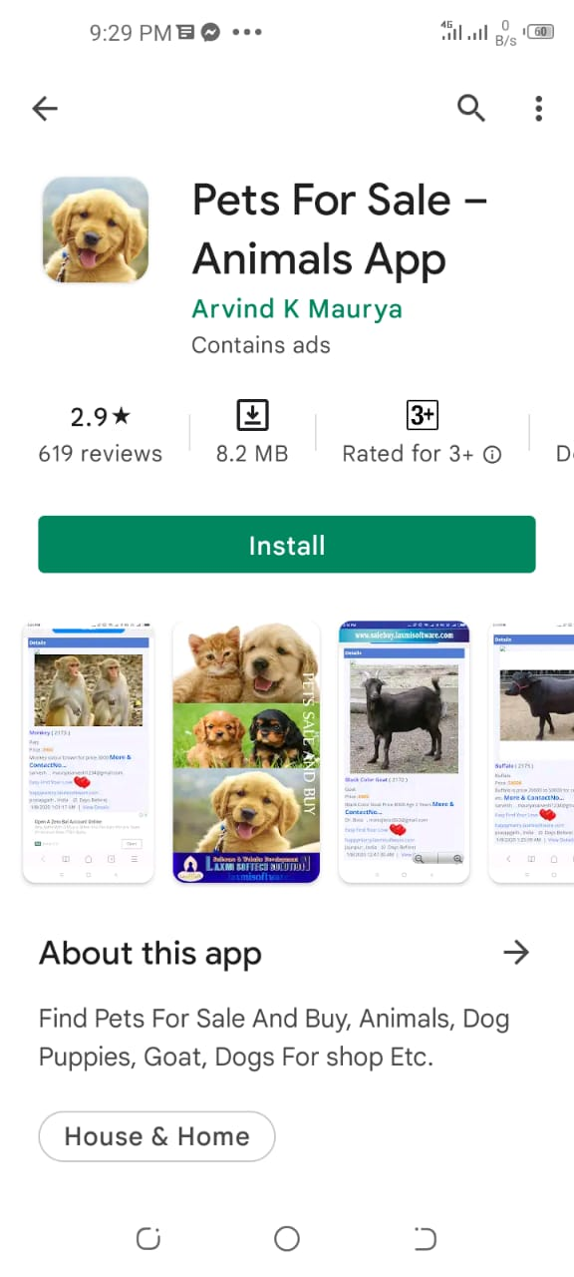

**Tracking App:**

This app only give tracking for cat and dogs. So this cannot fulfil the user requirement .

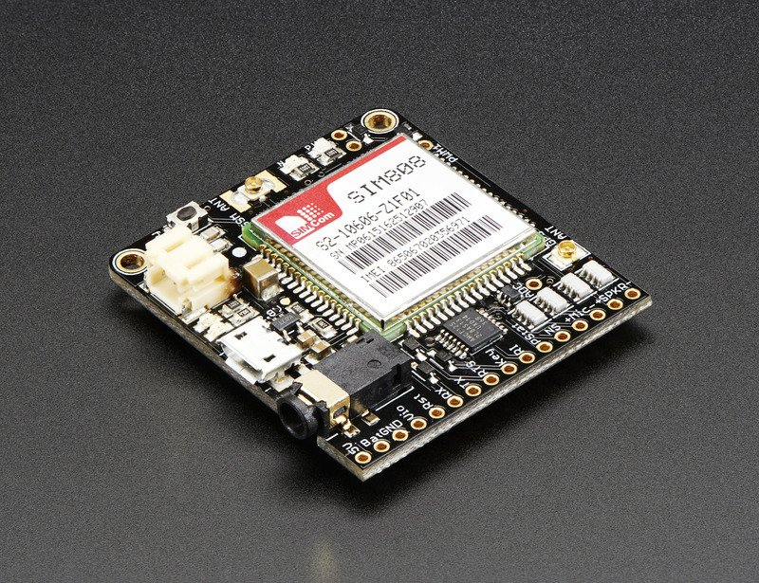

**Figure 2.1: Sample picture**

# Chapter 3: Requirement Analysis

Software Requirements Specification (SRS) report should be included in this chapter.

# Use Cases

Use cases are a widely used and highly regarded format for capturing requirements. Before writing functional requirement use cases can help you to understand the requirements in the way user expect. Following table presents you not only the template to write use case(s) as well as guides you to write each section with example.

|  |  |
| --- | --- |
| **Use Case ID:** | WM-1 |
| **Use Case Name:** | Login |
| **Actors:** | User, Doctor, Butcher. |
| **Description:** | Actor will give the preliminary information (Email, Password, etc.) and then he will login to system. |
| **Trigger:** | [Identify the event that initiates the use case. This could be an external event or system event that causes the use case to begin, or it could be the first step in the normal flow.] |
| **Preconditions:** | Actor must have access to the App Id. |
| **Postconditions:** | User successfully logged into the application  User can post order, request order and also can see the Animals lists, can see doctor, can see butcher and track animal. |
| **Normal Flow:** | User request for login by clicking login button.  User provides required information.  System checks validity of user’s information.  System will give access to system. |
| **Alternative Flows:**  **[Alternative Flow 1 – Not in Network]** | The System shows an error indicating invalid input according to validation criteria. |
| **Exceptions:** | None |
| **Includes:** | None |
| **Special Requirements:** | None |
| **Assumptions:** | None |
| **Notes and Issues:** | None |

|  |  |
| --- | --- |
| **Use Case ID:** | WM-2 |
| **Use Case Name:** | Sign Up |
| **Actors:** | User,Doctor,Butcher. |
| **Description:** | Actor will give the preliminary information (Email, Password, etc.) and then he can access the system. |
| **Preconditions:** | Actor must have access to the system. |
| **Postconditions:** | User can easily sign and sign out through system.  User can successfully access the application.  User can post order, request order, can see the Animals lists, can see doctor, can see butcher and track animal. |
| **Normal Flow:** | User request for login by clicking login button.  User provides required information.  System checks validity of user’s information.  System will give access to system. |
| **Alternative Flows:**  **[Alternative Flow 1 – Not in Network]** | The System shows an error indicating invalid input according to validation criteria. |
| **Exceptions:** | None |
| **Includes:** | None |
| **Special Requirements:** | None |
| **Assumptions:** | None |
| **Notes and Issues:** | None |

|  |  |
| --- | --- |
| **Use Case ID:** | WM-3 |
| **Use Case Name:** | Home |
| **Actors:** | User,Doctor,Butcher |
| **Description:** | Actor will use this ID overall interact with the application and call services. Here customer can see the posted animals and can purchase the animal and can buy animals feed as well.  Actors can appoint a doctor if their animal were ill.  Actors can appoint a butcher if require.  Actor can track their animal by using tracking services. |
| **Preconditions:** | Actor must have access to the system. He should be register to the System. And Logged in by a Authorized email, password. |
| **Postconditions:** | User will have the access to the system.  User can post order, request order, can see the Animals lists, can see doctor, can see butcher and track animal. |
| **Normal Flow:** | User will home screen |
| **Alternative Flows:**  **[Alternative Flow 1 – Not in Network]** | The System shows an error indicating invalid input according to validation criteria. |
| **Exceptions:** | None |
| **Includes:** | None |
| **Special Requirements:** | None |
| **Assumptions:** | None |
| **Notes and Issues:** | None |

# Functional Requirements

**Selling and purchasing**

Using the app user will be able to perform buying and selling of pets, animals etc.

**Feed Animals.**

Using this app user can buy any time of animal feed.

**Veterinary appointment**

Since we are adding a module for doctors to register them in the app so it will be quiet easier for the users to book an appointment with the doctor for their pets or animals checkup.

**Butcher services**

As we are adding a module for the butcher as well then the butchers will also be able to register their self into the app and offer their services online like booking an appointment etc.

**Tracking system**

A tracking module will be added, using it the user can track their animals or pets, what they need to is to dispatch a tracker with their pet or animal and register a account on our app then using the map we will track the pet or animal to show real location of it.

**Online bank transaction**

Online transaction system will be available in the app, if user want to pay online using the bank so they will be able to do it.

# 

# Non-Functional Requirements

**Nonfunctional Requirement**

Overall description is given below

**Performance Requirements**

a. Internet required

b. Mobile phone/Tablet

**Safety Requirements**

The system will not corrupt the data and will not cause any kind of issues to user-end.

**Security Requirements**

* User data is secured, difficult to hack user's information.
* The data will be stored on the server-side, so it is complex for any hacker to approach to the server for damaging the results.
* Basically, data will be most likely open source, so there will be any security threats.

**Software Quality Attributes**

There are many quality attributes but we are focusing on two main points.

a. Correctness.

b. Reliability.

# Chapter 4: Design and Architecture

This chapter will discuss the design and architecture of your system.

# System Architecture

User will open the application it will provide different service as mentioned. Our system architecture is simple and user friendly. The system architecture is as follows.

**Objectives**

* The whole world is moving towards digitalization
* Lack of time/busy routine
* Sale and purchase of pets
* Safety and security of pets
* Purpose of providing ease
* Feed, Medicine, Veterinary facility, Delivery, Butcher facility, Tracking system

# System Design

As system design varies from system to system, therefore you are required to explore which design pattern is suitable for your system. For guidelines an IEEE Recommended Practice for Software Design Descriptions (section 5 and 6) is provided with this template.

**Domain Model**

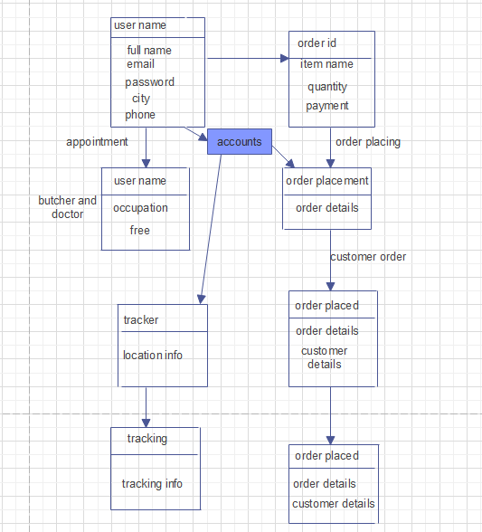

**Sequence Diagram for Sell and Purchase**

When the user entered the application and wants to select item to purchase, after selecting it will request data base for the item and database will return the data and order ID. After that the order details will be shown after tapping the order button order will be placed successfully.

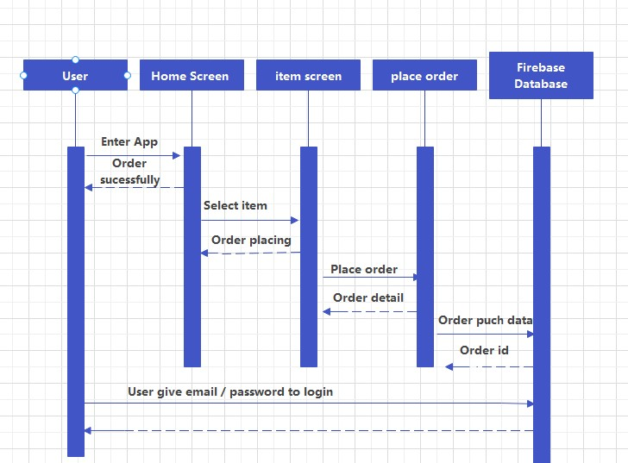

**Sequence Diagram for Veterinary Appointment**

When the user enters the application and wants an appointment with veterinary doctor or butcher. After tapping the book an appointment application will send a request to database and data base will send an appointment ID and details.

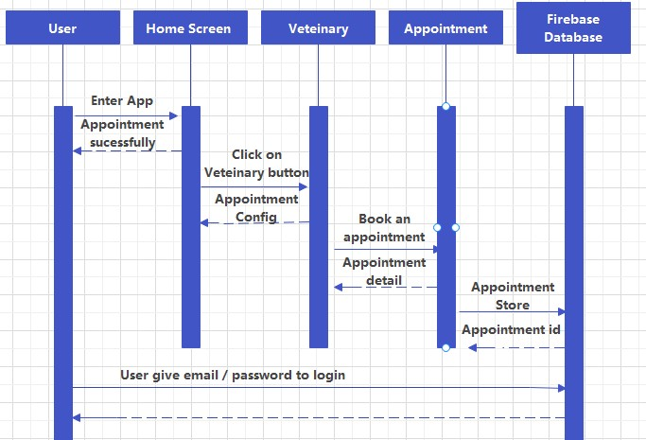

**Sequence Diagram for Tracking System**

When the user enter the application for tracking a pet they will tap the tracking button, after the tapping the button it will send a request database for pet location and database will respond with updated location of pet and will open the map on screen.

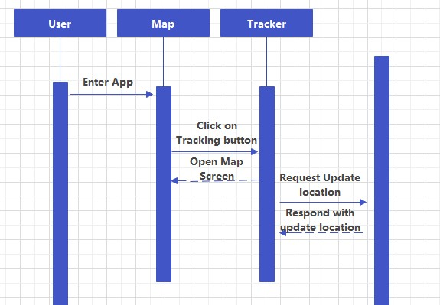

**Class Diagram**

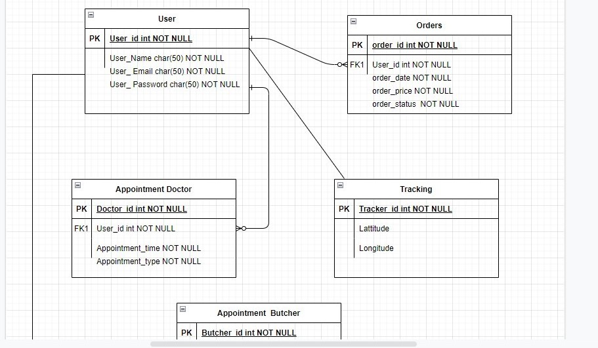

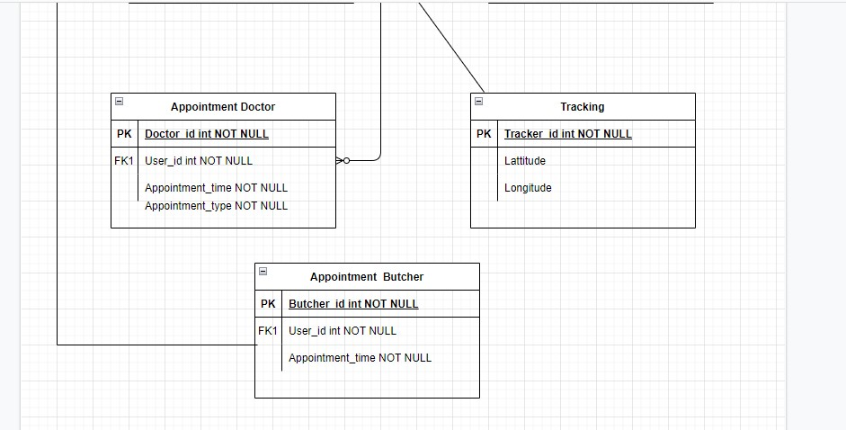

**Activity for login**

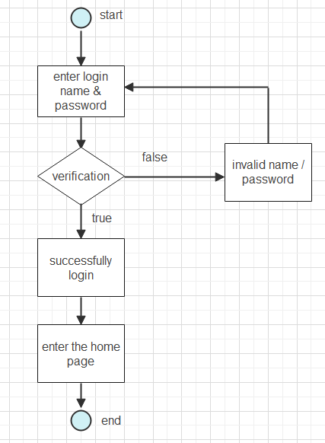

**Activity for Signup**

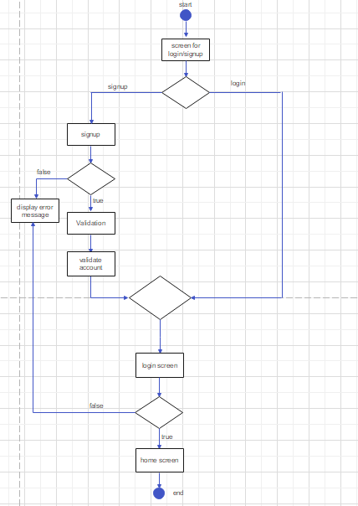

**Activity for Animals Feed**

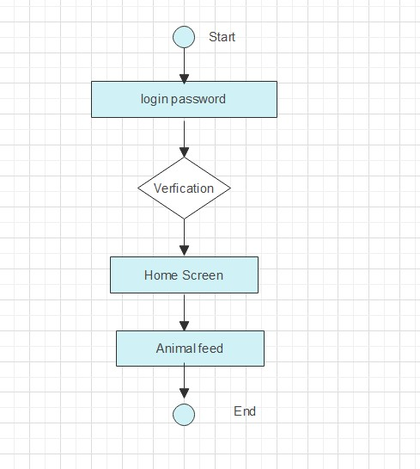

**Activity for Doctor**

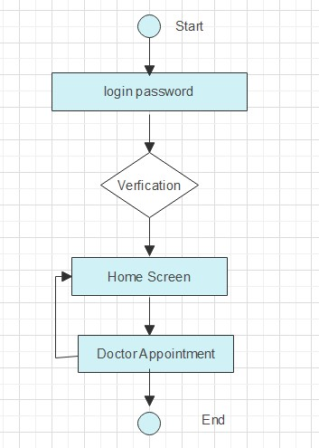

**Activity for Butcher**

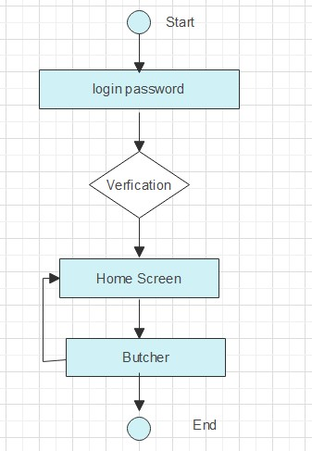

**Use Case for Admin**

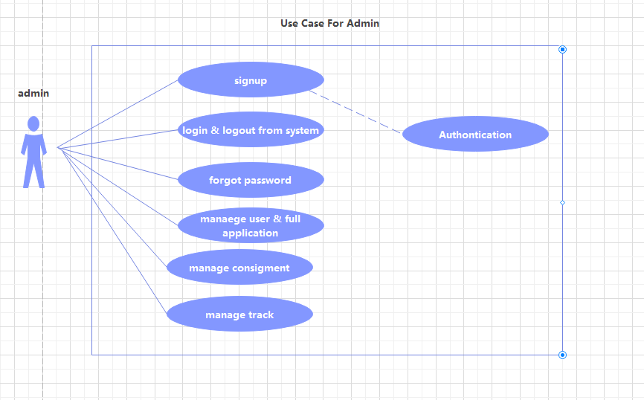

**Use Case for doctor**

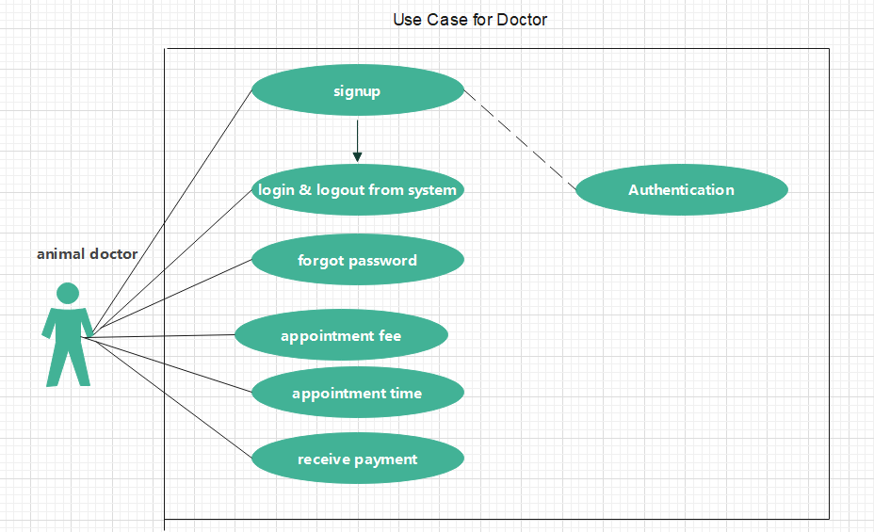

**Use case for butcher**

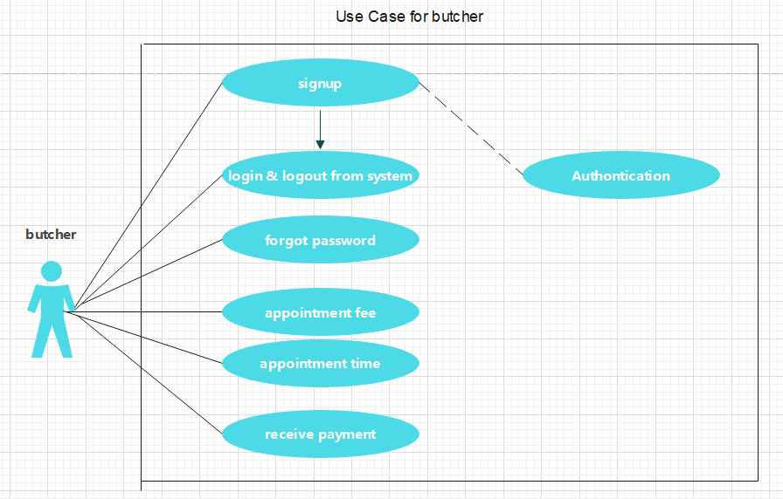

**Use case for customer**

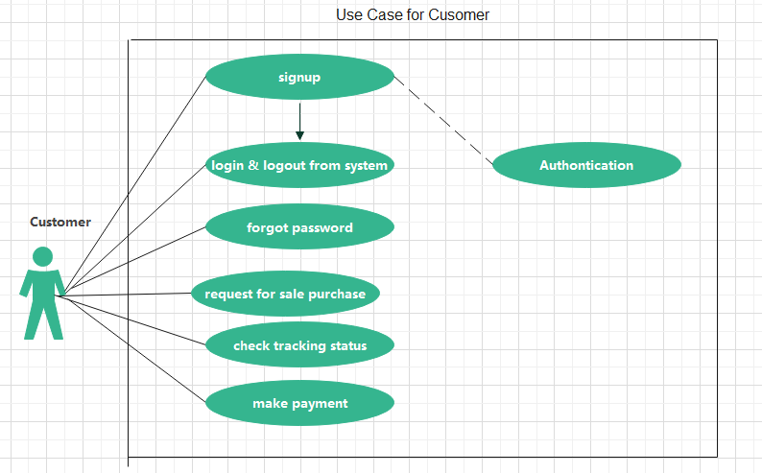

# Chapter 5: Implementation

This chapter will discuss implementation details supported by UML diagrams (if applicable). You will not put your source code here. Any of the following sections may be included based on your project.

# Component Diagram

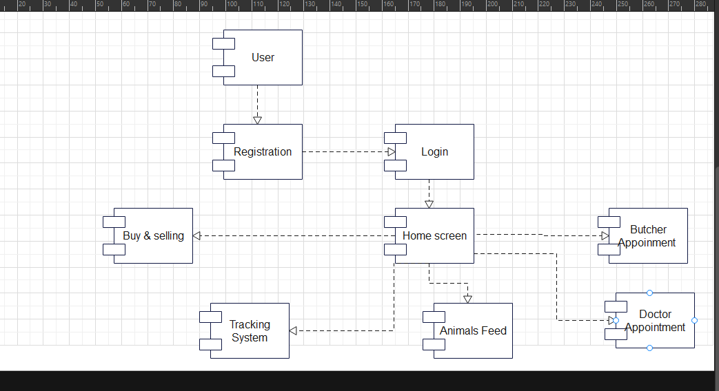

**Explanation:**

This project IOT Based Smart Animals Market with Tracking App with different technologies. We developed an android app with front end in xml and backend in java. The user can registers him/herself. The user can sell purchase and sell animals and they can also sell and purchase animals feed and most important the user can track their animals. We also have an admin panel which manages user data through firebase Database.

# Choice of Object Middleware

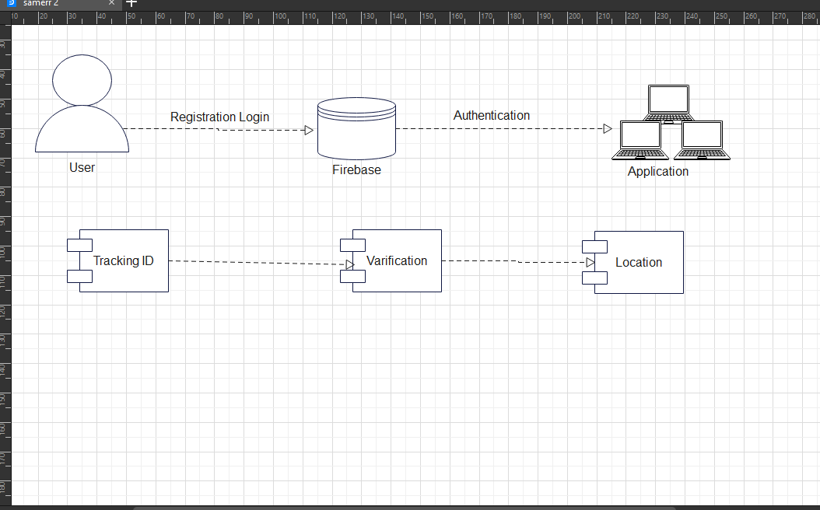

# User Interface

**Registration:**

# 

User can register themselves by putting their detail above and if the user have already an account he/she simply click on an “Already have an account login?” and can go to the login page which is given below.

**Login:**

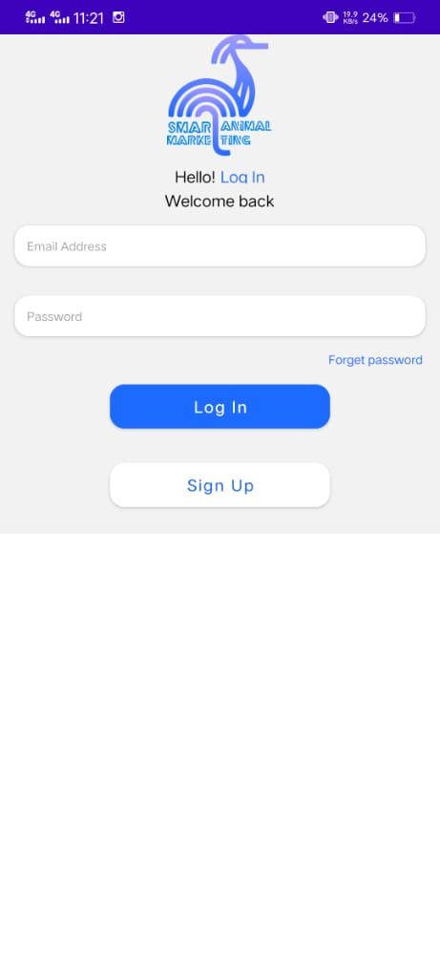

User can login as a guest or he/she can login via putting their credential in the above section where he/she asked for email and password that they he/she provides during registration time. If he/she forget password or didn’t have an account they can select the option accordingly.

**Home:**

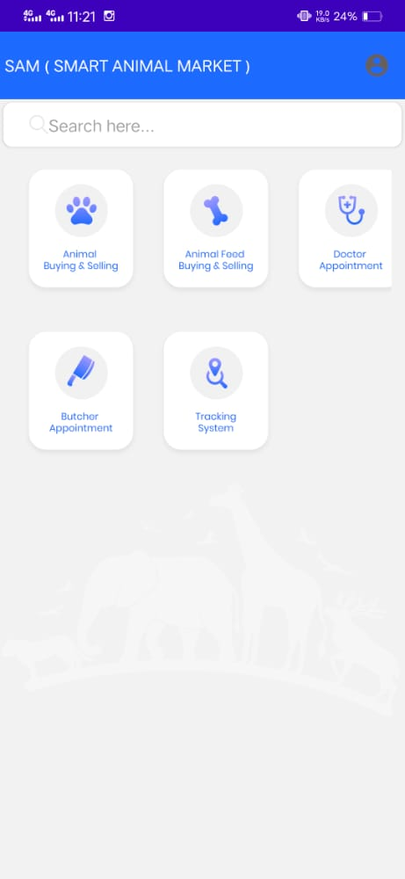

On the homepage section user will see Five Modules. First one is Buy and selling , second is Feeds, third is Doctor Appointment, fourth is Bucher Appointment and fifth modules is Tracking. will open next page where user can Click on one of module. And every module has own functions.

**Buying and Selling Page:**

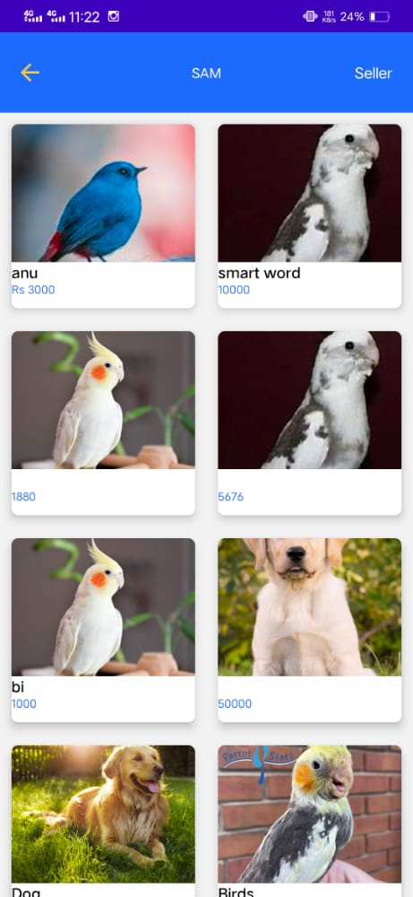

On this page user can sell and purchase their Favorite pets. For selling the pets, user can upload pictures of their pets.

**Animal food Buying and Selling Page:**

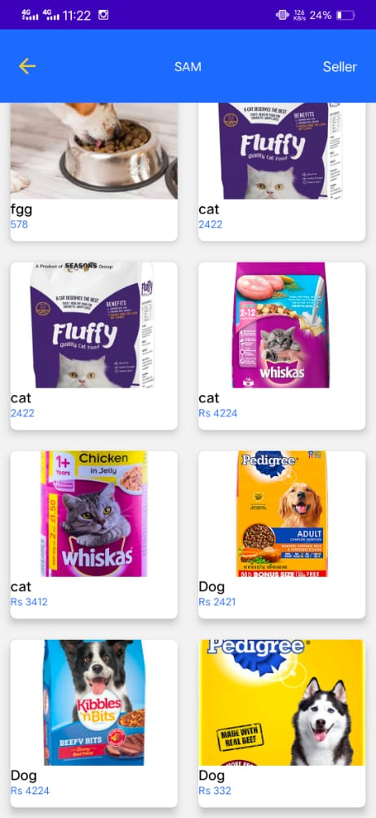

IN this page every food item will be available for animals, user can be buying feed for their pets.

# *Chapter 6*

**SOFTWARE TESTING**

Software testing is a process of executing a program or application with the intent of finding the software bugs. It can also be stated as the process of validating and verifying that a software program or application or product: Meets the business and technical requirements that guided its design and development.

### Deriving test

The specification for testing are derive from customer requirement, from the study of design code of software modules, from screen or visual interfaces through which the interacts with the system. Test-Case specifications in performed for system testing by keeping in mind several issues, which are discuss in following subtopics. With every possible situation.

### Test environment

**Android:**

The Application is tested with the required hardware and software requirement. Such as

* + - Android studio
    - Android mobile device
    - Tracking Device

**6.3 Testing identification**

A test was planned for every requirement to test the application. The test procedure adopted were detailed so that the system meets all requirement listed in SRS. The test were executed systematically, and its output verified, sequentially.

The system can be divided into modules:

* + - Login Application
    - See Animal buying & Selling
    - See Animal Feed Buying & Selling
    - See Doctor Appointment
    - See Bucher Appointment
    - See Tracking System

### Test Procedure

A testing strategy is decided for testing the system so that all modules are tested to fulfill all user requirements. A test strategy is a methodology that describe the various steps needs to be performed during testing and the time and efforts required for performing them. It requires a tester to play a role of an end user whereby they utilize most of the application’s features to ensure correct behavior.

* 1. **Test cases ()**

### Test Case Name: Signup

***Test Case 1***

|  |  |  |  |  |  |  |
| --- | --- | --- | --- | --- | --- | --- |
| **Project Name: IOT Based Smart Animals Market with Tracking App** | | | | | | |
| **Test Case 1** | | | | | | |
| **Test Case ID:** SPA_01 | | | |  | | |
| **Test Priority (Low/Medium/High):** High | | | | **Test Designed Date :** | | |
| **Module Name:** signup | | | |  | | |
| **Test Title:** Testsignup Details | | | | **Test Execution Date :** | | |
| **Description:** TestSee sign up Details page | | | |  | | |
| **Pre-Condition:** Open sign up page. | | | |  | | |
| **Dependencies:** user must be Login first. | | | |  | | |
| **Step** | **Test Steps** | **Test Data** | **Expected Result** | **Actual Result** | **Status**  **(Pass/Fail)** | **Notes** |
| 1 | User click on ”**See sing up detail**” button  (If Select As a Customer) |  | Only valid  Sign up detail show on screen | Sign up details not show on screen | Fail |  |

### **Test Case Name: Sign up**

***Test Case 2***

|  |  |  |  |  |  |  |
| --- | --- | --- | --- | --- | --- | --- |
| **Project Name: IOT Based Smart Animals Market with Tracking App** | | | | | | |
| **Test Case 2** | | | | | | |
| **Test Case ID:** SPA_02 | | | |  | | |
| **Test Priority (Low/Medium/High):** High | | | | **Test Designed Date :** | | |
| **Module Name:** signup | | | |  | | |
| **Test Title:** Testsignup Details | | | | **Test Execution Date :** | | |
| **Description:** TestSee sign up Details page | | | |  | | |
| **Pre-Condition:** Open sign up page. | | | |  | | |
| **Dependencies: open sign up page** | | | |  | | |
| **Step** | **Test Steps** | **Test Data** | **Expected Result** | **Actual Result** | **Status**  **(Pass/Fail)** | **Notes** |
| 1 | User click on ”**See sign up detail**” button (If Select As a Customer) |  | Only valid  signup detail show on screen | Signup details show on screen | pass |  |

### Test Case Name: Signup

***Test Case 3***

|  |  |  |  |  |  |  |
| --- | --- | --- | --- | --- | --- | --- |
| **Project Name: IOT Based Smart Animals Market with Tracking App** | | | | | | |
| **Test Case 3** | | | | | | |
| **Test Case ID:** SPA_03 | | | |  | | |
| **Test Priority (Low/Medium/High):** High | | | | **Test Designed Date :** | | |
| **Module Name:** signup | | | |  | | |
| **Test Title:** Testsignup Details | | | | **Test Execution Date :** | | |
| **Description:** TestSee sign up Details page | | | |  | | |
| **Pre-Condition:** Open sign up page. | | | |  | | |
| **Dependencies:** user must be Login first. | | | |  | | |
| **Step** | **Test Steps** | **Test Data** | **Expected Result** | **Actual Result** | **Status**  **(Pass/Fail)** | **Notes** |
| 1 | User click on ”**See sing up detail**” button  (If Select As a Doctor) |  | Only valid  Sign up detail show on screen | Sign up details not show on screen | Fail |  |

### **Test Case Name: Sign up**

***Test Case 4***

|  |  |  |  |  |  |  |
| --- | --- | --- | --- | --- | --- | --- |
| **Project Name: IOT Based Smart Animals Market with Tracking App** | | | | | | |
| **Test Case 4** | | | | | | |
| **Test Case ID:** SPA_04 | | | |  | | |
| **Test Priority (Low/Medium/High):** High | | | | **Test Designed Date :** | | |
| **Module Name:** signup | | | |  | | |
| **Test Title:** Testsignup Details | | | | **Test Execution Date :** | | |
| **Description:** TestSee sign up Details page | | | |  | | |
| **Pre-Condition:** Open sign up page. | | | |  | | |
| **Dependencies: open sign up page** | | | |  | | |
| **Step** | **Test Steps** | **Test Data** | **Expected Result** | **Actual Result** | **Status**  **(Pass/Fail)** | **Notes** |
| 1 | User click on ”**See sign up detail**” button (If Select As a Doctor) |  | Only valid  signup detail show on screen | Signup details show on screen | pass |  |

### Test Case Name: Signup

***Test Case 5***

|  |  |  |  |  |  |  |
| --- | --- | --- | --- | --- | --- | --- |
| **Project Name: IOT Based Smart Animals Market with Tracking App** | | | | | | |
| **Test Case 5** | | | | | | |
| **Test Case ID:** SPA_05 | | | |  | | |
| **Test Priority (Low/Medium/High):** High | | | | **Test Designed Date :** | | |
| **Module Name:** signup | | | |  | | |
| **Test Title:** Testsignup Details | | | | **Test Execution Date :** | | |
| **Description:** TestSee sign up Details page | | | |  | | |
| **Pre-Condition:** Open sign up page. | | | |  | | |
| **Dependencies:** user must be Login first. | | | |  | | |
| **Step** | **Test Steps** | **Test Data** | **Expected Result** | **Actual Result** | **Status**  **(Pass/Fail)** | **Notes** |
| 1 | User click on ”**See sing up detail**” button  (If Select As a Butcher) |  | Only valid  Sign up detail show on screen | Sign up details not show on screen | Fail |  |

### **Test Case Name: Sign up**

***Test Case 6***

|  |  |  |  |  |  |  |
| --- | --- | --- | --- | --- | --- | --- |
| **Project Name: IOT Based Smart Animals Market with Tracking App** | | | | | | |
| **Test Case 6** | | | | | | |
| **Test Case ID:** SPA_06 | | | |  | | |
| **Test Priority (Low/Medium/High):** High | | | | **Test Designed Date :** | | |
| **Module Name:** signup | | | |  | | |
| **Test Title:** Testsignup Details | | | | **Test Execution Date :** | | |
| **Description:** TestSee sign up Details page | | | |  | | |
| **Pre-Condition:** Open sign up page. | | | |  | | |
| **Dependencies: open sign up page** | | | |  | | |
| **Step** | **Test Steps** | **Test Data** | **Expected Result** | **Actual Result** | **Status**  **(Pass/Fail)** | **Notes** |
| 1 | User click on ”**See sign up detail**” button (If Select As a Butcher) |  | Only valid  signup detail show on screen | Signup details show on screen | pass |  |

**Test Case Name: Login**

***Test Case 7***

|  |  |  |  |  |  |  |
| --- | --- | --- | --- | --- | --- | --- |
| **Project Name: IOT Based Smart Animals Market with Tracking App** | | | | | | |
| **Test Case 7** | | | | | | |
| **Test Case ID:** SPA_07 | | | |  | | |
| **Test Priority (Low/Medium/High):** High | | | | **Test Designed Date :** | | |
| **Module Name:** Login | | | |  | | |
| **Test Title:** TestLogin Details | | | | **Test Execution Date :** | | |
| **Description:** TestSee Login Details page | | | |  | | |
| **Pre-Condition:** Open Login page. | | | |  | | |
| **Dependencies:** user must be Signup first. | | | |  | | |
| **Step** | **Test Steps** | **Test Data** | **Expected Result** | **Actual Result** | **Status**  **(Pass/Fail)** | **Notes** |
| 1 | User click on ”**See** Login **detail**” button |  | Only valid  Login detail show on screen | Login details not show on screen | Fail |  |

### **Test Case Name: Login**

***Test Case 8***

|  |  |  |  |  |  |  |
| --- | --- | --- | --- | --- | --- | --- |
| **Project Name: IOT Based Smart Animals Market with Tracking App** | | | | | | |
| **Test Case** | | | | | | |
| **Test Case ID:** SPA_08 | | | |  | | |
| **Test Priority (Low/Medium/High):** High | | | | **Test Designed Date :** | | |
| **Module Name:** Login | | | |  | | |
| **Test Title:** TestLogin Details | | | | **Test Execution Date :** | | |
| **Description:** TestSee Login Details page | | | |  | | |
| **Pre-Condition:** Open Login page. | | | |  | | |
| **Dependencies:** user must be Signup first. | | | |  | | |
| **Step** | **Test Steps** | **Test Data** | **Expected Result** | **Actual Result** | **Status**  **(Pass/Fail)** | **Notes** |
| 1 | User click on ”**See** Login **detail**” button |  | Only valid  Login detail show on screen | Login details show on screen | pass |  |

# *Chapter 7*

**CONCLUSSION AND FUTURE WORK**

IOT Based Smart Animals Market with Tracking App very useful for Pet Customer, Animal doctor and Bucher. It is used to Track animal and also used for sell and purchasing. Animal Doctor see patient appointment time. In this Chapter we will describe discussion and future work.

### Discussion

Our project given platform to find Pet Animal for Customer by using Tracking Device. Customer can Sell Purchase animals and also purchase animal feed. Customer can be appoint doctor for their animal treatment. Butcher services are also available in our App.

**7.2. Conclusion**

IOT Based Smart Animals Market with Tracking App is a most efficient way to find your Pet animals. Rather than wasting your time and physical energy to find your missing pet animal you can easily track your animal by using our app. You can also buy sell animals also purchasing their feeding. User can have every possible services regarding their animal.

### Future work

In future work we can add chat and voice. They also communicate by voice or chat. In future we can add an alert of when animal go too far away from home on time.